THIS IS NOT NORMAL.

As a result of constant bombardment of news, the outlandish statements of political influencers, and the increase of disinformation, the public has become immune to over-the-top rhetoric and blatant lies. A new word has surfaced to describe how the media covers the firehose of ridiculous conspiracies and claims coming from right-wing pundits and politicians.
Sane washing is the practice of restating someone's rhetoric to seem more palatable or acceptable. It is the practice of dismissing outlandish statements as simply “Trump being Trump.” The practice does a disservice to us as voters and citizens. It normalizes extreme rhetoric, often violent and vile, by restating radical or incoherent statements in more palatable terms, making extreme views seem more mainstream and acceptable. By doing so it can significantly impact public perception of political figures and their claims.
So, let’s not mince words here and engage in sane washing ourselves. Let’s take a moment and recognize just a few of the crazy and incoherent ramblings in which just the former president has engaged. The examples are far too numerous so here we have limited the discussion to those more recent incidents and statements.
The bottom line to ask yourself and others is whether this is a person who you truly trust with the nuclear codes. Be honest, this is not normal.

HANNIBAL LECTER:
Trump has repeatedly brought up Hannibal Lecter at campaign rallies and speeches.
- "They're arriving from everywhere. They're coming from all corners of the globe, from correctional facilities and mental health institutions. You know, they lose it when I mention, 'the late great Hannibal Lecter,' right?" Possibly conflating asylum seekers (a legal status) with mental asylums.
- He has referred to Lecter as "a delightful gentleman" and quoted the line "He'd love to have you for dinner."
- Trump has used phrases like "the late great Hannibal Lecter" multiple times, despite Lecter not being dead in the fictional universe.
- “Silence of the lamb! The late great Hannibal Lecter. It is a wonderful man.” Trump repeatedly has said Hannibal Lecter, a fictional serial killer, is a “great man” who deserves our “congratulations.”
- He seems confused about whether Hannibal Lecter is a character or the man who played him in a movie. He’s remarked, “Hannibal Lecter, how great an actor was he?” Trump has said he loves Lecter claiming because the actor once said, “I love Donald Trump” in a TV interview.
- By the end of The Silence of the Lambs, Lecter has escaped from the State Hospital for the Criminally Insane and is stalking his next victim. Yet Trump just loves yelling “Hannibal Lecter!” at his rallies, even if it is crazy.

MAGNETS AND WATER:
At a rally in Iowa in January 2024, Trump went off on a strange tale about magnets. “Think of it, magnets,” he said. “Now all I know about magnets is this, give me a glass of water, let me drop it on the magnets, that’s the end of the magnets. Why didn’t they use John Deere? Why didn’t they bring in the John Deere people? Do you like John Deere? I like John Deere.”

Ron Filipkowski, editor-in-chief for Meidas Touch, said, “Dementia Trump is riffing on his magnets in a water story, then tries to pander to the Iowa audience by bringing John Deere into the story because what’s in his head to repeat in Iowa over and over is ‘John Deere,’ and the whole deal just short circuits into an addled, sweaty mess.”
Need we tell you that magnets are not affected by water, whether pored on them or immersed in water.
Donald Trump Ridiculed for Bizarre Magnet Remarks at Iowa Rally - Newsweek
There’s a Crazy Index for Donald Trump – Baptist News Global

SHARKS:
During a campaign event in Las Vegas in June 2024, Trump went off-script and expressed his dislike for sharks. He described a hypothetical scenario involving electric boats, suggesting that if such a boat sank, he would prefer to be electrocuted rather than face a shark nearby. He stated, "I’m not getting near the shark," highlighting his fear of these creatures. He further criticized sharks, saying they are "not our friends" and mocked their behavior, claiming they take a bite and swim away without finishing their meal, calling it "wasteful".

His remarks about sharks have become a recurring theme, as he previously mentioned similar sentiments during a campaign stop in Iowa in late 2023.
"It must be because of M.I.T., my relationship with M.I.T., very smart. I say, 'What would happen if the boat sank from its weight and you're in the boat and you have this tremendously powerful battery, and the battery is now underwater, and there's a shark that's approximately 10 yards over there?" Trump said. "By the way, lot of shark attacks lately. Did you notice that?" He described asking the boat manufacturer if, in the hypothetical scenario, he should get electrocuted or jump near the shark. "I'll take electrocution every single time," Trump said. "I'm not getting near the shark." “Sharks are last on my list - other than perhaps the losers and haters of the World!”
Trump mocked over shark comments during Nevada campaign event (usatoday.com)
Trump Rants About Sharks, and Everyone Just Pretends It's Normal - The Atlantic

THEY ARE EATING THE PETS IN OHIO:
It was Trump’s running mate, JD Vance, that first brought the claim out from the deep recesses of the internet that Haitian immigrants are eating the pets of residents in Ohio. But it was Donald Trump who brought it to a prime time viewing public.
Frankly, how can we ever forget that moment during the presidential debate with Kamala Harris on September 10, 2024, when Trump made the following statement: "In Springfield, they're consuming dogs. They're eating cats. They're devouring the pets of local residents. This is what is transpiring in our nation, and it's quite unfortunate." This baseless claim was made in reference to Haitian immigrants who have legally resettled in Springfield, Ohio.

Click on image below for video play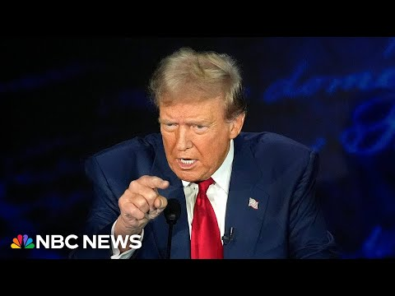
Trump's comments amplified unfounded rumors that had been circulating in right-wing corners of the internet. These rumors began spreading on social media platforms, with posts claiming that Haitian immigrants were responsible for the disappearance of ducks from parks and pets from homes.
We do not really need to tell you that the claims are false, because of course they are. Despite Trump's assertions, there is no credible evidence to support these claims. Springfield police officials have stated that they have received no reports of such occurrences. City officials have confirmed that they have not received any allegations regarding Haitians consuming pets. It has been readily debunked by multiple sources. Even JD Vance, while simultaneously doubling down on the story and yet admitting the veracity of the story is dubious. He confesses that he is willing to “create stories” to draw attention to issues he feels is important. Translation - he is willing to lie. What doesn’t matter to them is that the innocent residents and immigrants in Ohio must bear the brunt of their lies. The claims have contributed to the demonization of Haitian immigrants and could potentially incite racial violence. Springfield has experienced bomb threats resulting in the closure of city hall and local schools.
As is typical for the former president, he continues to remain steadfast in demonizing the legal Haitian immigrants. Both Trump and Vance have stated that they will continue to call legal Haitian immigrants “illegals”. Further, Trump has said he would deport legal Haitian immigrants if re-elected by revoking Temporary Protected Status (TPS) and "bring them back to their country." He specifically mentioned deporting Haitian migrants living legally in Springfield, Ohio, saying "You have to remove the people. You cannot destroy — we cannot destroy our country." This stance is consistent with Trump's previous attempts during his presidency to end TPS for about 400,000 migrants from various countries. Legal experts have noted that revoking TPS would be necessary for Trump to deport these legal immigrants, as people with TPS generally cannot be deported unless they commit a crime.
How a fringe online claim about immigrants eating pets made its way to the debate stage (nbcnews.com)
‘A very old political trope’: the racist US history behind Trump’s Haitian pet eater claim | Donald Trump | The Guardian
Trump repeats false claim about immigrants 'eating' dogs, cats' in Ohio (youtube.com)
JD Vance admits he is willing to ‘create stories’ to get media attention | US elections 2024 | The Guardian
JD Vance defends baseless rumor about Haitian immigrants eating pets | CNN Politics
Trump says he would revoke Temporary Protected Status for Haitian migrants in Springfield if elected | CNN Politics

ROBERT E. LEE, GETTYSBURG AND THE PIRATE JACK SPARROW:
In an April rally, after describing the Battle of Gettysburg, in which about 50,000 soldiers died, in Trump’s words, “so beautiful in so many different ways,” he delivered a fake quote from Confederate Gen. Robert E. Lee in a bad Captain Jack Sparrow voice: “Robert E. Lee, who’s no longer in favor — did you ever notice it? He’s no longer in favor. ‘Never fight uphill, me boys, never fight uphill.’ They were fighting uphill.” He said, “Wow, that was a big mistake.” He lost his big general. “Never fight uphill, me boys,” but it was too late.
Trump sounds off on the Civil War, again goes after John McCain and criticizes magnets - ABC News

WOMEN AS VOTERS.
Once again, Trump has a long history of making derogatory comments about women. To list them all would simply take too much time. Let’s address some of the more recent ones.
- While his polling with women falters, Trump praised his supporters’ husbands for “allowing” their wives to attend his campaign rallies without them. “Somebody said, ‘Women don’t like Donald Trump,’” he said in Johnstown, Pa., Aug. 30. “I said, ‘I think that’s wrong. I think they love me.’ I love them.” He pointed to a group of women from North Carolina who have attended 227 of his rallies: “They’re wealthy as hell. Look at them. They’ve got nothing but cash. Their husbands are great. But they allow them to go all over the country.” He recalled a conversation with some of their husbands where he asked, “How do you put up with this? Your wives are traveling all over the place. Do you mind?” The husbands told him: “‘We trust our wives, sir. We trust them implicitly.” Trump’s response was to say the women are “always perfectly coiffed … they’re beautiful.”

- Trump has cast himself as a “protector” of women, saying in battleground Pennsylvania that he will save them from fear and loneliness, and they will no longer have to think about abortion. “You will no longer be abandoned, lonely or scared. You will no longer be in danger. ... You will no longer have anxiety from all of the problems our country has today,” Trump said. “You will be protected, and I will be your protector.” He has continued to embrace the overturning of Roe v Wade striping women of bodily autonomy yet continuing to claim that "You will no longer be thinking about abortion," Trump said. "Because we've done something that nobody else could have done. It is now where it always had to be, with the states and a vote of the people." Need we point out that by having States decide then women themselves can no longer decide.

- In the latest attack on women critical of him. Trump lashed out at the hosts of "The View" after Vice President Kamala Harris appeared on the show. He called the hosts "degenerates" and "dumb women" in posts on Truth Social and X (formerly Twitter). Trump specifically targeted host Sunny Hostin, saying: "I think the other one asking the question is dumber than Kamala. She's a dummy. I've watched her over the years. That is one dumb – that is one dumb woman." The attacks are part of a long-standing pattern of trump making derogatory comments about women, particularly those who criticize him.

Trump Praises Men for Letting Wives Travel Solo to MAGA Rallies (thedailybeast.com)
Trump’s Volunteers: ‘Beautiful Ladies’ From a Secretive Evangelical Church - The New York Times (nytimes.com)
Election 2024: Trump, GOP candidates struggle with outreach to female voters | AP News
Trump repeats claims that women will 'no longer be thinking about abortion' if he becomes president - ABC News (go.com)

CONTOLLING THE WEATHER:
Trump has not directly claimed that Democrats can control the weather or create hurricanes. That gem came first from Majorie Taylor Greene.
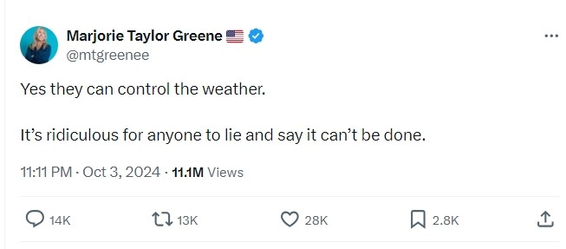
While Trump hasn't directly promoted weather control conspiracies, his statements have been seen as contributing to a broader climate of misinformation surrounding weather events and disaster response. Trump has accused Democrats and the Biden administration of mishandling hurricane relief efforts, stating: "the Federal Government, and Democrat Governor of the State, are deliberately withholding help from people in Republican areas". At a rally in Michigan, Trump alleged that "Kamala spent all her FEMA funds, billions of dollars, on illegal aliens, many of whom should not be in our country". He asserted that Democrats "stole FEMA money, just like robbing a bank, to give to illegal immigrants so they can vote for them this election season".
Governors from North Carolina and Georgia have pushed back against the claims admitting that they have received the aid they requested from the federal government. The Federal Emergency Management Agency (FEMA) has had to create a "Hurricane Rumor Response" page to counter various false claims, including some amplified by Trump, such as the idea that FEMA doesn't have hurricane relief money because it has all been spent on people living in the U.S. illegally.

Hurricane news: Trump, Musk, and Greene’s conspiracy theories about FEMA and Democrats have sinister implications for the election. (slate.com)
Government controls weather conspiracy theories flourish amid storms (usatoday.com)

VERMIN AND POISONING THE BLOOD OF OUR COUNTRY:
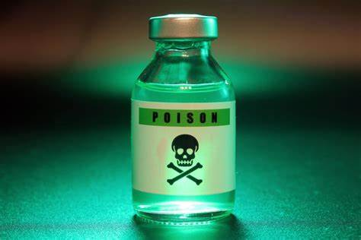
Trump continues to echo Hitler while lashing out at immigrants, complaining that immigration is “poisoning the blood of our country” and describing migrants and political opponents as “vermin.”
At a Veterans Day rally in New Hampshire, Trump vowed to "root out the communists, Marxists, fascists and the radical left thugs that live like vermin within the confines of our country." In an interview with The National Pulse, Trump claimed that immigrants who are in the country without authorization are "poisoning the blood of America."

Trump expects to get away with dehumanizing anti-immigrant rhetoric (msnbc.com)
Trump compares political opponents to 'vermin' who he will 'root out,' alarming historians - ABC News (go.com)
Trump campaign defends "vermin" speech amid fascist comparisons (axios.com)

THE PURGE AS POLICY:
Trump made comments that some have compared to the premise of "The Purge" movie series.
At a rally in Erie, Pennsylvania, Trump suggested that "one really violent day" or "one rough hour, and I mean real rough" could end crime "immediately." He proposed that Rep. Mike Kelly (R-Pa.) could be put in charge for that "violent day" and tell police: "Don't touch them, let them rob your store." Trump's comments were widely compared to the plot of "The Purge" films, where all crime is legal for one night each year. Some historians and critics also drew comparisons to historical events like Kristallnacht, though Trump supporters contested this comparison.

SCHOOLS PERFORMING TRANSGENDER OPERATIONS:
Donald Trump has made several false and inflammatory claims about schools performing transgender operations on children. He has repeatedly claimed that schools are secretly performing gender-affirming surgeries on children without parental consent. At a Moms for Liberty event in August 2024, Trump stated: "Your kid goes to school and comes home a few days later with an operation. The school decides what's going to happen with your child." He reiterated this claim at a campaign rally in Wisconsin, saying: "Can you imagine being a parent, sending your son off to school with a loving farewell, only for him to return home after a traumatic surgery?"
These claims are entirely false. There is no evidence of schools performing or arranging gender-affirming surgeries for students. Experts and fact-checkers have debunked these statements, pointing out that:
- Schools do not have the facilities or personnel to perform such surgeries.
- Gender-affirming surgeries require parental consent for minors.
- Even common medications like Advil require explicit parental permission in schools.

In Mosinee, Wisconsin, days before meeting Harris on the debate stage for the first time, Trump repeated the same brazen claim at a campaign rally. “Can you imagine you’re a parent and your son leaves the house and you say, ‘Jimmy, I love you so much. Go have a good day in school.’ And your son comes back with a brutal operation. Can you even imagine this? What the hell is wrong with our country,” he said.
Of course, he has rifted on this theme by adding more attacks against trans individuals. During the debate with Harris he claimed “Now she wants to do transgender operations on illegal aliens that are in prison” and “This is a radical left liberal that would do this.” On other occasions he has claimed that Olympic women’s welterweight boxing gold medalist Imane Khelif of Algeria “transitioned” to female. The statements are false. Trump's campaign has not provided any evidence to support these claims when asked.

Trump is using anti-LGBTQ+ rhetoric to distract from his abortion claims (19thnews.org)
Fact check: Trump falsely claims schools are secretly sending children for gender-affirming surgeries | CNN Politics

